MY PLANET
Unscramble the tiles to reveal a message.
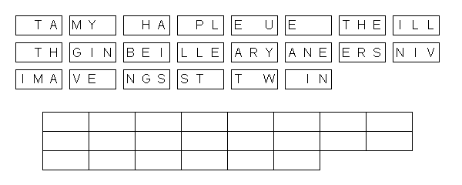

The Solar System
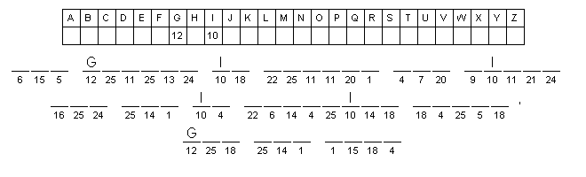

The Universe
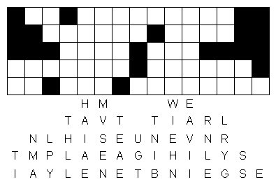

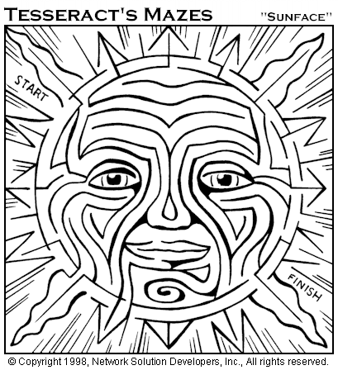

Our Solar System

S T H E S P U N I S T H E L A
A U R G L E S T O B J E C T I
N S N U T H E S O L M A R S Y
S T T A E M U H E Y X O E Y B
T O I E R T J G R R H V O K P
Y W S I R U U Q K U W I Z N U
X F U R B O P F D C O I V G P
N R U T A S I H H R Z X T Y B
V M K W X M T D C E J V U H H
T F X H Q R E B S M W Z Z E P
T W A M A E R Z X S U N E V L
R F D E I Q X T V K E H D W T
W T D Q M M M I Q Q N G E N R
I G K Z Z V G W E C G M T L E
B G N E P T U N E L D T Q C T

ASTEROIDS
EARTH
JUPITER
MARS
MERCURY
MOON
NEPTUNE
PLUTO
SATURN
URANUS
VENUS
__ __ __ __ __ __ __ __ __ __ __ __ __ __ __ __ __ __ __ __ __ __ __ __

__ __ __ __ __ __ __ __ __ __ __ __ __ __ __ __

